Anexo 11. Alertas incremento de amenaza bajo escenarios de cambio climático para las UFH de Tibaná, Boyacá
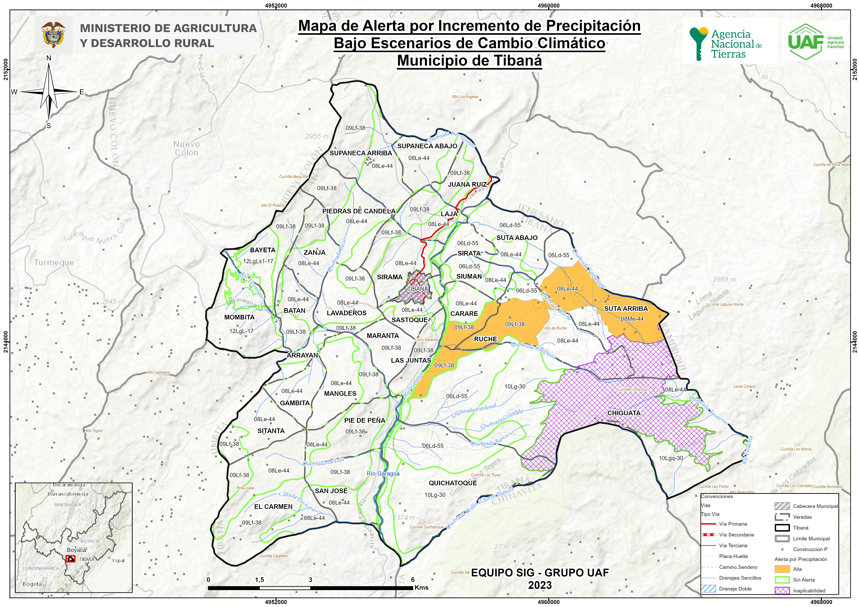

Tipo | UFH | Polígono | Erosión | Amenaza | Escenario (pptn) | Alerta CC | Área (Ha)
6 | 06Ld-55 | 1 | Ligera | Media | 11% a 20% | Alta | 0,62
 |  |  |  | Alta | 11% a 20% | Muy Alta | 6,44
6 | 06Ld-55 | 2 | Ligera | Media | -9% a 10% | Media | 670,74
 |  |  |  | Alta | -9% a 10% | Alta | 119,82
6 | 06Ld-55 | 3 | Ligera | Media | -9% a 10% | Media | 116,45
 |  |  |  | Alta | -9% a 10% | Alta | 355,19
 |  |  |  | Muy alta | -9% a 10% | Muy alta | 0,80
 |  |  |  | Media | 11% a 20% | Alta | 15,56
 |  |  |  | Alta | 11% a 20% | Muy Alta | 95,88
 |  |  |  | Muy alta | 11% a 20% | Muy Alta | 0,07
6 | 06Ld-55 | 4 | Ligera | Alta | -9% a 10% | Alta | 0,31
8 | 08Le-44 | 1 | Ligera | Media | -9% a 10% | Media | 1,25
 |  |  |  | Alta | -9% a 10% | Alta | 0,23
8 | 08Le-44 | 2 | Ligera | Media | -9% a 10% | Media | 0,85
 |  |  |  | Alta | -9% a 10% | Alta | 0,74
8 | 08Le-44 | 3 | Ligera | Media | 11% a 20% | Alta | 0,00
8 | 08Le-44 | 3 | Sin evidencia | Media | 11% a 20% | Alta | 0,13
8 | 08Le-44 | 4 | Ligera | Media | -9% a 10% | Media | 0,35
 |  |  |  | Alta | -9% a 10% | Alta | 1,18
 |  |  |  | Media | 11% a 20% | Alta | 303,77
 |  |  |  | Alta | 11% a 20% | Muy Alta | 50,03
8 | 08Le-44 | 4 | Sin evidencia | Media | 11% a 20% | Alta | 1,78
 |  |  |  | Alta | 11% a 20% | Muy Alta | 1,66
8 | 08Le-44 | 5 | Ligera | Media | -9% a 10% | Media | 120,73
 |  |  |  | Alta | -9% a 10% | Alta | 118,74
8 | 08Le-44 | 5 | Sin evidencia | Media | -9% a 10% | Media | 1,61
 |  |  |  | Alta | -9% a 10% | Alta | 3,90
8 | 08Le-44 | 6 | Ligera | Media | -9% a 10% | Media | 728,05
 |  |  |  | Alta | -9% a 10% | Alta | 328,34
8 | 08Le-44 | 6 | Moderada | Media | -9% a 10% | Media | 0,01
 |  |  |  | Alta | -9% a 10% | Alta | 1,08
8 | 08Le-44 | 7 | Ligera | Media | -9% a 10% | Media | 0,87
 |  |  |  | Media | 11% a 20% | Alta | 109,48
 |  |  |  | Alta | 11% a 20% | Muy Alta | 65,74
8 | 08Le-44 | 8 | Ligera | Media | -9% a 10% | Media | 89,07
 |  |  |  | Alta | -9% a 10% | Alta | 198,46
 |  |  |  | Muy alta | -9% a 10% | Muy alta | 0,54
8 | 08Le-44 | 9 | Ligera | Media | -9% a 10% | Media | 916,75
 |  |  |  | Alta | -9% a 10% | Alta | 725,97
8 | 08Le-44 | 9 | Moderada | Media | -9% a 10% | Media | 1,62
 |  |  |  | Alta | -9% a 10% | Alta | 6,64
8 | 08Le-44 | 9 | No suelo | Alta | -9% a 10% | Alta | 0,01
8 | 08Le-44 | 9 | Sin evidencia | Media | -9% a 10% | Media | 1,23
 |  |  |  | Alta | -9% a 10% | Alta | 1,34
8 | 08Le-44 | 10 | Ligera | Alta | -9% a 10% | Alta | 0,17
8 | 08Me-44 | 1 | Ligera | Media | 11% a 20% | Alta | 0,13
 |  |  |  | Alta | 11% a 20% | Muy Alta | 0,06
8 | 08Me-44 | 2 | Ligera | Media | 11% a 20% | Alta | 180,00
 |  |  |  | Alta | 11% a 20% | Muy Alta | 26,45
8 | 08Me-44 | 3 | Ligera | Media | 11% a 20% | Alta | 24,85
 |  |  |  | Alta | 11% a 20% | Muy Alta | 3,81
9 | 09LaiL-38 | 1 | Ligera | Media | -9% a 10% | Media | 13,89
 |  |  |  | Alta | -9% a 10% | Alta | 16,28
9 | 09LaiL-38 | 2 | Ligera | Media | -9% a 10% | Media | 57,40
 |  |  |  | Alta | -9% a 10% | Alta | 55,20
 |  |  |  | Muy alta | -9% a 10% | Muy alta | 0,06
9 | 09Le-38 | 1 | Ligera | Media | -9% a 10% | Media | 0,19
 |  |  |  | Alta | -9% a 10% | Alta | 1,38
9 | 09Lf-38 | 1 | Ligera | Media | -9% a 10% | Media | 0,05
 |  |  |  | Media | -9% a 10% | Media | 0,00
9 | 09Lf-38 | 2 | Ligera | Media | -9% a 10% | Media | 115,79
 |  |  |  | Alta | -9% a 10% | Alta | 10,50
 |  |  |  | Media | -9% a 10% | Media | 961,84
 |  |  |  | Alta | -9% a 10% | Alta | 344,48
9 | 09Lf-38 | 2 | Moderada | Media | -9% a 10% | Media | 6,74
 |  |  |  | Alta | -9% a 10% | Alta | 0,63
9 | 09Lf-38 | 2 | Sin evidencia | Media | -9% a 10% | Media | 54,03
 |  |  |  | Alta | -9% a 10% | Alta | 29,52
9 | 09Lf-38 | 3 | Ligera | Media | -9% a 10% | Media | 334,71
 |  |  |  | Alta | -9% a 10% | Alta | 45,39
 |  |  |  | Media | 11% a 20% | Alta | 15,46
 |  |  |  | Alta | 11% a 20% | Muy Alta | 1,46
9 | 09Lf-38 | 4 | Ligera | Media | -9% a 10% | Media | 282,70
 |  |  |  | Alta | -9% a 10% | Alta | 146,00
9 | 09Lf-38 | 5 | Ligera | Media | -9% a 10% | Media | 361,84
 |  |  |  | Alta | -9% a 10% | Alta | 152,50
9 | 09Lf-38 | 5 | Moderada | Media | -9% a 10% | Media | 19,14
 |  |  |  | Alta | -9% a 10% | Alta | 14,50
9 | 09Lf-38 | 5 | Sin evidencia | Media | -9% a 10% | Media | 101,10
 |  |  |  | Alta | -9% a 10% | Alta | 56,76
9 | 09Lf-38 | 6 | Ligera | Media | -9% a 10% | Media | 0,02
 |  |  |  | Alta | -9% a 10% | Alta | 0,04
9 | 09Lf-38 | 7 | Ligera | Media | -9% a 10% | Media | 0,87
 |  |  |  | Alta | -9% a 10% | Alta | 0,52
9 | 09Lf-38 | 8 | Ligera | Media | -9% a 10% | Media | 0,08
 |  |  |  | Alta | -9% a 10% | Alta | 0,22
10 | 10Lf-30 | 1 | Moderada | Media | -9% a 10% | Media | 0,21
10 | 10Lf-30 | 1 | Sin evidencia | Media | -9% a 10% | Media | 0,06
 |  |  |  | Alta | -9% a 10% | Alta | 0,08
10 | 10Lfq-30 | 1 | Ligera | Media | -9% a 10% | Media | 0,05
10 | 10Lfq-30 | 2 | Ligera | Media | -9% a 10% | Media | 0,30
 |  |  |  | Alta | -9% a 10% | Alta | 0,35
11 | 11LfL-23 | 1 | Ligera | Media | -9% a 10% | Media | 103,91
 |  |  |  | Alta | -9% a 10% | Alta | 29,86
11 | 11LfL-23 | 2 | Ligera | Media | -9% a 10% | Media | 106,03
 |  |  |  | Alta | -9% a 10% | Alta | 51,65
11 | 11LfL-23 | 3 | Ligera | Media | -9% a 10% | Media | 0,02
 |  |  |  | Alta | -9% a 10% | Alta | 0,01

