Anexo 11. Alertas incremento de amenaza bajo escenarios de cambio climático para las UFH de Ventaquemada, Boyacá
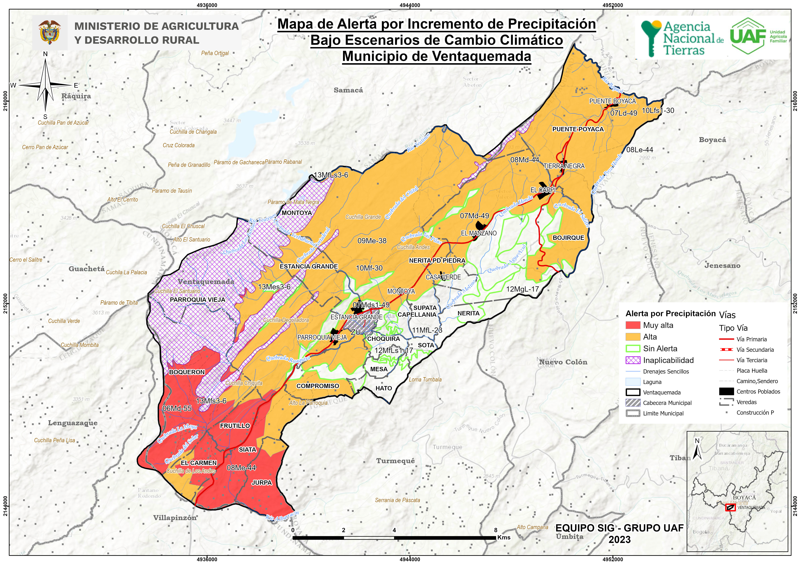

Tipo | UFH | Polígono | Amenaza | Escenario (pptn) | Alerta CC | Área (Ha)
6 | 06Md-55 | 1 | Media | 11% a 20% | Alta | 290,95
6 | 06Md-55 | 1 | Alta | 11% a 20% | Muy Alta | 306,54
6 | 06Md-55 | 2 | Media | 21% a 30% | Muy Alta | 0,80
6 | 06Md-55 | 2 | Alta | 21% a 30% | Muy Alta | 3,93
6 | 06Md-55 | 3 | Media | 11% a 20% | Alta | 33,32
6 | 06Md-55 | 3 | Alta | 11% a 20% | Muy Alta | 129,22
7 | 07Ld-49 | 1 | Media | 11% a 20% | Alta | 67,49
7 | 07Ld-49 | 1 | Alta | 11% a 20% | Muy Alta | 1,16
7 | 07Md-49 | 1 | Media | -9% a 10% | Media | 75,16
7 | 07Md-49 | 1 | Alta | -9% a 10% | Alta | 0,20
7 | 07Md-49 | 2 | Media | 11% a 20% | Alta | 2,95
7 | 07Md-49 | 2 | Alta | 11% a 20% | Muy Alta | 0,01
7 | 07Md-49 | 3 | Media | 11% a 20% | Alta | 0,08
7 | 07Md-49 | 4 | Media | -9% a 10% | Media | 1206,98
7 | 07Md-49 | 4 | Alta | -9% a 10% | Alta | 298,06
7 | 07Md-49 | 4 | Media | 11% a 20% | Alta | 545,15
7 | 07Md-49 | 4 | Alta | 11% a 20% | Muy Alta | 19,33
7 | 07Md-49 | 4 | Media | 21% a 30% | Muy Alta | 6,43
7 | 07Mds1-49 | 1 | Media | -9% a 10% | Media | 27,16
7 | 07Mds1-49 | 1 | Alta | -9% a 10% | Alta | 26,73
8 | 08Le-44 | 1 | Media | -9% a 10% | Media | 181,23
8 | 08Le-44 | 1 | Alta | -9% a 10% | Alta | 5,85
8 | 08Le-44 | 1 | Media | 11% a 20% | Alta | 59,60
8 | 08Le-44 | 1 | Alta | 11% a 20% | Muy Alta | 14,11
8 | 08Md-44 | 1 | Media | -9% a 10% | Media | 142,24
8 | 08Md-44 | 1 | Alta | -9% a 10% | Alta | 3,48
8 | 08Md-44 | 2 | Media | -9% a 10% | Media | 40,74
8 | 08Md-44 | 2 | Alta | -9% a 10% | Alta | 2,81
8 | 08Md-44 | 2 | Media | 11% a 20% | Alta | 173,46
8 | 08Md-44 | 2 | Alta | 11% a 20% | Muy Alta | 13,59
8 | 08Me-44 | 1 | Media | 11% a 20% | Alta | 404,13
8 | 08Me-44 | 1 | Alta | 11% a 20% | Muy Alta | 353,27
8 | 08Me-44 | 1 | Media | 21% a 30% | Muy Alta | 121,47
8 | 08Me-44 | 1 | Alta | 21% a 30% | Muy Alta | 188,91
8 | 08Me-44 | 2 | Media | -9% a 10% | Media | 92,92
8 | 08Me-44 | 2 | Alta | -9% a 10% | Alta | 51,23
8 | 08Me-44 | 3 | Media | -9% a 10% | Media | 272,22
8 | 08Me-44 | 3 | Alta | -9% a 10% | Alta | 46,91
8 | 08Me-44 | 4 | Media | 11% a 20% | Alta | 49,88
8 | 08Me-44 | 4 | Alta | 11% a 20% | Muy Alta | 13,79
8 | 08Me-44 | 5 | Media | -9% a 10% | Media | 543,11
8 | 08Me-44 | 5 | Alta | -9% a 10% | Alta | 90,83
8 | 08Me-44 | 5 | Media | 11% a 20% | Alta | 225,70
8 | 08Me-44 | 5 | Alta | 11% a 20% | Muy Alta | 2,24
8 | 08Me-44 | 6 | Media | 11% a 20% | Alta | 64,17
8 | 08Me-44 | 6 | Alta | 11% a 20% | Muy Alta | 7,84
8 | 08Me-44 | 6 | Media | 21% a 30% | Muy Alta | 31,89
8 | 08Me-44 | 6 | Alta | 21% a 30% | Muy Alta | 13,67
8 | 08Me-44 | 7 | Media | 11% a 20% | Alta | 1,01
9 | 09Me-38 | 1 | Media | 11% a 20% | Alta | 36,70
9 | 09Me-38 | 1 | Alta | 11% a 20% | Muy Alta | 7,62
9 | 09Me-38 | 1 | Media | 21% a 30% | Muy Alta | 0,13
9 | 09Me-38 | 2 | Media | -9% a 10% | Media | 149,67
9 | 09Me-38 | 2 | Alta | -9% a 10% | Alta | 36,73
9 | 09Me-38 | 2 | Media | 11% a 20% | Alta | 215,17
9 | 09Me-38 | 2 | Alta | 11% a 20% | Muy Alta | 74,28
9 | 09Me-38 | 3 | Media | -9% a 10% | Media | 82,16
9 | 09Me-38 | 3 | Alta | -9% a 10% | Alta | 19,69
9 | 09Me-38 | 4 | Media | -9% a 10% | Media | 53,18
9 | 09Me-38 | 4 | Alta | -9% a 10% | Alta | 3,59
9 | 09Me-38 | 5 | Media | -9% a 10% | Media | 1502,73
9 | 09Me-38 | 5 | Alta | -9% a 10% | Alta | 405,90
9 | 09Me-38 | 5 | Media | 11% a 20% | Alta | 711,64
9 | 09Me-38 | 5 | Alta | 11% a 20% | Muy Alta | 178,10
9 | 09Me-38 | 6 | Media | -9% a 10% | Media | 0,98
9 | 09Me-38 | 6 | Alta | -9% a 10% | Alta | 0,19
10 | 10Lfs1-30 | 1 | Media | -9% a 10% | Media | 25,60
10 | 10Lfs1-30 | 1 | Alta | -9% a 10% | Alta | 8,14
10 | 10Lfs1-30 | 1 | Media | 11% a 20% | Alta | 2,41
10 | 10Lfs1-30 | 1 | Alta | 11% a 20% | Muy Alta | 1,95
10 | 10Mf-30 | 1 | Media | 11% a 20% | Alta | 62,02
10 | 10Mf-30 | 1 | Alta | 11% a 20% | Muy Alta | 32,06
10 | 10Mf-30 | 2 | Media | -9% a 10% | Media | 6,81
10 | 10Mf-30 | 2 | Alta | -9% a 10% | Alta | 0,50
10 | 10Mf-30 | 2 | Media | 11% a 20% | Alta | 7,52
10 | 10Mf-30 | 2 | Alta | 11% a 20% | Muy Alta | 1,85
10 | 10Mf-30 | 3 | Media | 11% a 20% | Alta | 10,13
10 | 10Mf-30 | 3 | Alta | 11% a 20% | Muy Alta | 4,29
10 | 10Mf-30 | 4 | Media | -9% a 10% | Media | 233,04
10 | 10Mf-30 | 4 | Alta | -9% a 10% | Alta | 302,66
10 | 10Mf-30 | 4 | Media | 11% a 20% | Alta | 312,05
10 | 10Mf-30 | 4 | Alta | 11% a 20% | Muy Alta | 243,52
10 | 10Mf-30 | 5 | Media | 11% a 20% | Alta | 57,11
10 | 10Mf-30 | 5 | Alta | 11% a 20% | Muy Alta | 157,29
10 | 10Mf-30 | 6 | Media | -9% a 10% | Media | 50,90
10 | 10Mf-30 | 6 | Alta | -9% a 10% | Alta | 124,94
10 | 10Mf-30 | 7 | Media | -9% a 10% | Media | 17,66
10 | 10Mf-30 | 7 | Alta | -9% a 10% | Alta | 20,97
11 | 11MfL-23 | 1 | Media | -9% a 10% | Media | 0,24
11 | 11MfL-23 | 1 | Media | 11% a 20% | Alta | 5,59
11 | 11MfL-23 | 1 | Alta | 11% a 20% | Muy Alta | 7,69
11 | 11MfL-23 | 2 | Media | -9% a 10% | Media | 0,00
11 | 11MfL-23 | 2 | Alta | -9% a 10% | Alta | 0,04
11 | 11MfL-23 | 3 | Media | -9% a 10% | Media | 663,11
11 | 11MfL-23 | 3 | Alta | -9% a 10% | Alta | 352,94
12 | 12MfLs1-17 | 1 | Media | 11% a 20% | Muy Alta | 0,00
12 | 12MfLs1-17 | 2 | Media | -9% a 10% | Media | 16,36
12 | 12MfLs1-17 | 2 | Alta | -9% a 10% | Alta | 40,23
12 | 12MfLs1-17 | 3 | Media | -9% a 10% | Media | 11,80
12 | 12MfLs1-17 | 3 | Alta | -9% a 10% | Alta | 32,17
12 | 12MgL-17 | 1 | Media | -9% a 10% | Media | 169,33
12 | 12MgL-17 | 1 | Alta | -9% a 10% | Alta | 36,37
12 | 12MgL-17 | 2 | Media | -9% a 10% | Media | 81,47
12 | 12MgL-17 | 2 | Alta | -9% a 10% | Alta | 32,21
12 | 12MgL-17 | 3 | Media | -9% a 10% | Media | 22,99
12 | 12MgL-17 | 3 | Alta | -9% a 10% | Alta | 24,29
13 | 13Mes3-6 | 1 | Media | -9% a 10% | Media | 23,32
13 | 13Mes3-6 | 1 | Alta | -9% a 10% | Alta | 4,82
13 | 13MfLs3-6 | 1 | Media | 11% a 20% | Alta | 16,88
13 | 13MfLs3-6 | 1 | Alta | 11% a 20% | Muy Alta | 0,18
13 | 13Mfs3-6 | 1 | Media | -9% a 10% | Media | 6,91
13 | 13Mfs3-6 | 1 | Alta | -9% a 10% | Alta | 0,36
13 | 13Mfs3-6 | 1 | Media | 11% a 20% | Alta | 18,24
13 | 13Mfs3-6 | 1 | Alta | 11% a 20% | Muy Alta | 28,49

