ANEXO 11. Alertas incremento de amenaza bajo escenarios de cambio climático para las UFH aptas de Pradera, Valle del Cauca
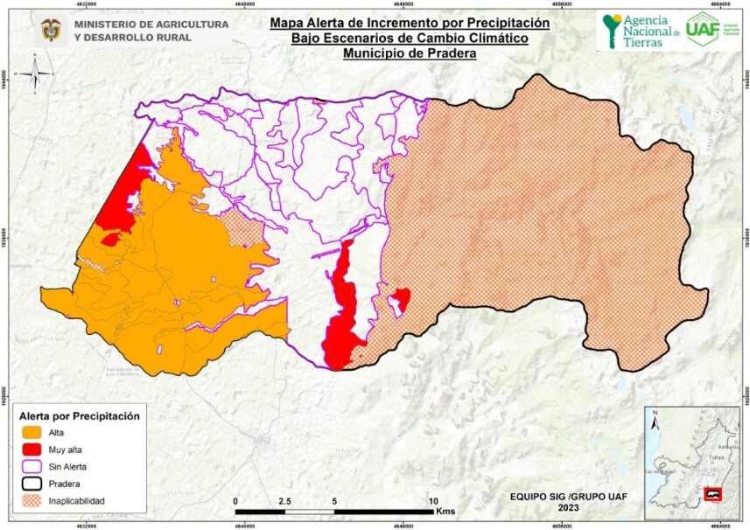
Tipo | UFH | Polígono | Amenaza remoción en masa | Escenario (pptn) | Alerta | Área (Ha)
3 | 03Qa-73 | 1 | Media | 11% - 20% | Alta | 7,78
3 | 03Qa-73 | 2 | Media | 11% - 20% | Alta | 31,54
3 | 03Qa-73 | 3 | Media | (-9%) - 10% | Media | 183,56
3 | 03Qa-73 | 4 | Media | 11% - 20% | Alta | 567,36
3 | 03Qa-73 | 4 | Alta | 11% - 20% | Muy alta | 0,47
3 | 03Qa-73 | 5 | Media | 11% - 20% | Alta | 61,30
3 | 03Qa-73 | 6 | Media | 11% - 20% | Alta | 186,53
3 | 03Qa-73 | 6 | Alta | 11% - 20% | Muy alta | 5,26
3 | 03Qb-73 | 1 | Media | (-9%) - 10% | Media | 218,61
3 | 03Qb-73 | 1 | Alta | (-9%) - 10% | Alta | 55,72
3 | 03Qb-73 | 1 | Muy alta | (-9%) - 10% | Muy alta | 0,36
3 | 03Qc-73 | 1 | Media | 11% - 20% | Alta | 5,30
 |  |  |  | 21% a 30% | Alta | 12,77
3 | 03Qc-73 | 1 | Alta | 11% - 20% | Muy alta | 17,46
 |  |  |  | 21% a 30% | Muy alta | 18,83
3 | 03Qc-73 | 1 | Muy alta | 11% - 20% | Muy alta | 1,14
 |  |  |  | 21% a 30% | Muy alta | 0,43
3 | 03Ra-73 | 1 | Media | 11% - 20% | Alta | 295,36
3 | 03Ra-73 | 2 | Media | (-9%) - 10% | Media | 44,63
 |  |  |  | 11% - 20% | Alta | 75,76
3 | 03Ra-73 | 3 | Media | 11% - 20% | Alta | 75,32
3 | 03Ra-73 | 4 | Media | 11% - 20% | Media | 116,91
3 | 03Ra-73 | 5 | Media | 11% - 20% | Alta | 35,54
3 | 03Wa-73 | 1 | Media | 11% - 20% | Alta | 73,04
3 | 03Wa-73 | 2 | Media | 11% - 20% | Alta | 202,23
3 | 03Wa-73 | 3 | Media | (-9%) - 10% | Media | 410,30
 |  |  |  | 11% - 20% | Alta | 173,91
3 | 03Wa-73 | 4 | Media | (-9%) - 10% | Media | 172,98
3 | 03Wa-73 |  | Alta | (-9%) - 10% | Alta | 3,28
3 | 03Wa-73 | 6 | Media | 11% - 20% | Alta | 229,77
3 | 03Wa-73 | 7 | Media | (-9%) - 10% | Media | 0,02
5 | 05Qcp-61 | 1 | Media | (-9%) - 10% | Media | 18,74
5 | 05Qcp-61 | 1 | Alta | (-9%) - 10% | Alta | 7,75
5 | 05Qcp-61 | 1 | Media | 11% - 20% | Alta | 60,05
5 | 05Qcp-61 | 1 | Alta | 11% - 20% | Muy alta | 62,05
5 | 05Qd-61 | 1 | Media | (-9%) - 10% | Media | 38,30
5 | 05Qd-61 | 1 | Alta | (-9%) - 10% | Alta | 20,18
5 | 05Qds1-61 | 1 | Media | (-9%) - 10% | Media | 5,46
5 | 05Qds1-61 | 1 | Alta | (-9%) - 10% | Alta | 80,63
6 | 06Qa-55 | 1 | Media | 11% - 20% | Alta | 72,92
6 | 06Qa-55 | 1 | Alta | 11% - 20% | Muy alta | 0,12
6 | 06Qb-55 | 1 | Media | (-9%) - 10% | Media | 780,03
 |  |  |  | 11% - 20% | Alta | 1459,95
 |  |  |  | 21% a 30% | Muy alta | 9,86
6 | 06Qb-55 | 1 | Alta | (-9%) - 10% | Alta | 36,31
 |  |  |  | 11% - 20% | Muy alta | 24,58
 |  |  |  | 21% a 30% | Muy alta | 5,26
6 | 06Qb-55 | 2 | Media | (-9%) - 10% | Media | 229,04
6 | 06Qb-55 | 2 | Alta | (-9%) - 10% | Alta | 34,26
6 | 06Qbip-55 | 1 | Media | (-9%) - 10% | Media | 97,14
6 | 06Qbip-55 | 1 | Alta | (-9%) - 10% | Alta | 0,41
6 | 06Qcp-55 | 1 | Media | (-9%) - 10% | Media | 560,79
6 | 06Qcp-55 | 1 | Alta | (-9%) - 10% | Alta | 310,09
6 | 06Qcp-55 | 1 | Muy alta | (-9%) - 10% | Muy alta | 2,01
6 | 06Rb-55 | 1 | Media | (-9%) - 10% | Media | 846,18
6 | 06Rb-55 | 1 | Alta | (-9%) - 10% | Alta | 95,90
7 | 07Qa-49 | 1 | Media | 11% - 20% | Alta | 127,30
7 | 07Qa-49 | 1 | Alta | 11% - 20% | Muy alta | 0,38
7 | 07Qa-49 | 2 | Media | (-9%) - 10% | Media | 803,64
7 | 07Qa-49 | 2 | Alta | (-9%) - 10% | Alta | 1,93
7 | 07Qa-49 | 2 | Media | 11% - 20% | Alta | 1395,35
7 | 07Qa-49 | 2 | Alta | 11% - 20% | Muy alta | 7,83
7 | 07Qai-49 | 1 | Media | 11% - 20% | Alta | 124,24
7 | 07Qai-49 | 1 | Alta | 11% - 20% | Muy alta | 1,38
7 | 07Qai-49 | 2 | Media | (-9%) - 10% | Media | 99,07
7 | 07Qai-49 | 2 | Alta | (-9%) - 10% | Alta | 2,50
7 | 07Qe2s1-49 | 1 | Media | (-9%) - 10% | Media | 225,64
7 | 07Qe2s1-49 | 1 | Alta | (-9%) - 10% | Alta | 44,57
7 | 07Ra-49 | 1 | Media | 11% - 20% | Alta | 641,92
7 | 07Ra-49 | 2 | Media | 11% - 20% | Alta | 214,96
7 | 07Ra-49 | 3 | Media | (-9%) - 10% | Media | 629,13
 |  |  |  | 11% - 20% | Alta | 164,98
7 | 07Rai-49 | 1 | Media | 11% - 20% | Alta | 20,24
7 | 07Wa-49 | 1 | Media | (-9%) - 10% | Media | 191,20
7 | 07Wa-49 | 2 | Media | 11% - 20% | Alta | 392,70
7 | 07Wa-49 | 3 | Media | 11% - 20% | Alta | 263,46
7 | 07Wa-49 | 4 | Media | 11% - 20% | Alta | 146,38
7 | 07Wa-49 | 5 | Media | (-9%) - 10% | Media | 57,09
10 | 10Lf2s1-30 | 1 | Media | 11% - 20% | Alta | 43,17
10 | 10Lf2s1-30 | 1 | Alta | 11% - 20% | Alta | 23,83
10 | 10Lf2s1-30 | 2 | Media | (-9%) - 10% | Media | 44,50
10 | 10Lf2s1-30 | 2 | Alta | (-9%) - 10% | Alta | 46,20
10 | 10Lf2s1-30 | 3 | Media | (-9%) - 10% | Media | 11,55
10 | 10Lf2s1-30 | 4 | Alta | (-9%) - 10% | Alta | 19,56
10 | 10Qf2s1-30 | 1 | Media | (-9%) - 10% | Media | 476,84
10 | 10Qf2s1-30 | 1 | Alta | (-9%) - 10% | Alta | 426,45
10 | 10Qf2s1-30 | 2 | Media | 11% - 20% | Alta | 547,30
10 | 10Qf2s1-30 | 2 | Alta | 11% - 20% | Muy alta | 39,35
10 | 10Qf3s2-30 | 1 | Media | 11% - 20% | Alta | 306,06
10 | 10Qf3s2-30 | 1 | Alta | 11% - 20% | Muy alta | 66,65
10 | 10Qf3s2-30 | 1 | Muy alta | 11% - 20% | Muy alta | 2,50
10 | 10Qf3s2-30 | 2 | Media | (-9%) - 10% | Media | 115,30
10 | 10Qf3s2-30 | 2 | Alta | (-9%) - 10% | Alta | 7,13
10 | 10Qf3s2-30 | 3 | Media | (-9%) - 10% | Media | 1304,18
10 | 10Qf3s2-30 | 3 | Alta | (-9%) - 10% | Alta | 129,24
10 | 10Qf3s2-30 | 3 | Muy alta | (-9%) - 10% | Muy alta | 0,07
11 | 11Lf-23 | 1 | Media | (-9%) - 10% | Media | 118,17
11 | 11Lf-23 | 1 | Alta | (-9%) - 10% | Alta | 139,43
11 | 11Lf-23 | 1 | Muy alta | (-9%) - 10% | Muy alta | 1,64
11 | 11Lfs1-23 | 1 | Media | (-9%) - 10% | Media | 0,00
11 | 11Lfs1-23 | 1 | Alta | (-9%) - 10% | Alta | 0,12
11 | 11Lfs1-23 | 1 | Muy alta | (-9%) - 10% | Muy alta | 0,49

